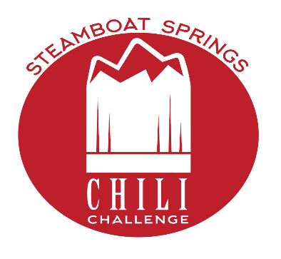
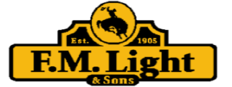

The 2024 Downtown Chili Challenge will be Saturday September 28, 2024.
Here is what you need to know!
The Downtown Chili Challenge is Presented by FM Light &Sons and Powered by Main Street Steamboat!
The event takes place on 7th street from the alley to Yampa and in the 7th Street parking lot. Our volunteers will direct you to where you can set up.
The Downtown Chili Challenge is a Fundraiser for Main Street Steamboat. The proceeds are used to offset the cost of advertising for Restaurant week.
Chili booths should be set up and ready to judge by 10 am. Blind judging takes place at 10:15. The judges use the same criteria for all categories. The list includes flavor, texture, presentation, and originality. The event opens to the public at 11 and ends at 3 pm. Awards are given out at 2:30. Awards are given for Best Red Chili, Best Green Chili, Best Salsa, and Best Corn Bread. People’s Choice Awards go to Best Red and Best Green Chili. There are no People’s Choice awards for salsa or cornbread. If the judges are so moved, they MAY give out awards for the Best Booth Presentation OR Looks Like Team Spirit awards.
Main Street Steamboat will provide serving cups, spoons, and tickets to vote for People’s Choice in the tasting kits. Please do not provide alternate tasting cups.
Admission is free, the band starts at 11 am. Tasting kits are $15.00 for adults and $10 for kids. Chili entrants should provide a minimum of 10 gallons (more is better, YOU REALLY DON’T WANT TO RUN OUT!!it takes at least 15 gallons to win People’s Choice but use your discretion). Arrive with your Chili HOT and ready to serve.
Please Note that there is no electricity at the challenge venue. You can use Sterno or something like it to keep your chili warm. You will also need a 1 oz ladle. Anything bigger makes a mess!
You will need a 10x10 tent, tables and whatever you choose to decorate your booth. There is NO ELECTRICITY, so you will need to have a way to keep your chili warm. We will provide a place card with your restaurant and chili name so customers can identify you for the People’s Choice Award. You are welcome to have additional signage to promote your restaurant and Chef. If you would LOVE to participate, but feel you may be short staffed, we will do our best to find you someone to serve your chili. The more notice the better. Main Street counts on you to help us promote the event. We would love for you to talk it up and get folks down to the event to vote on the best chili. WE ENCOURAGE SHAMELESS SELF PROMOTION

Downtown Chili Challenge Registration Form

There is no fee to enter. Please return via email (Lisa@mainstreetsteamboat.com) or drop off at our office at 141 9th St, as you would like them to appear in press releases and other media:

Name of Restaurant_______________________________________________
Name of Chef____________________________________________________
Green Chili Name_________________________________________________
Red Chili Name___________________________________________________
Salsa____________________________________________________________
Corn Bread_______________________________________________________

Please direct questions to Lisa@mainstreetsteamboat.com

